#U1 - Nephi

Spanish Addresses

Do Not Calls

Please return to the Delta English
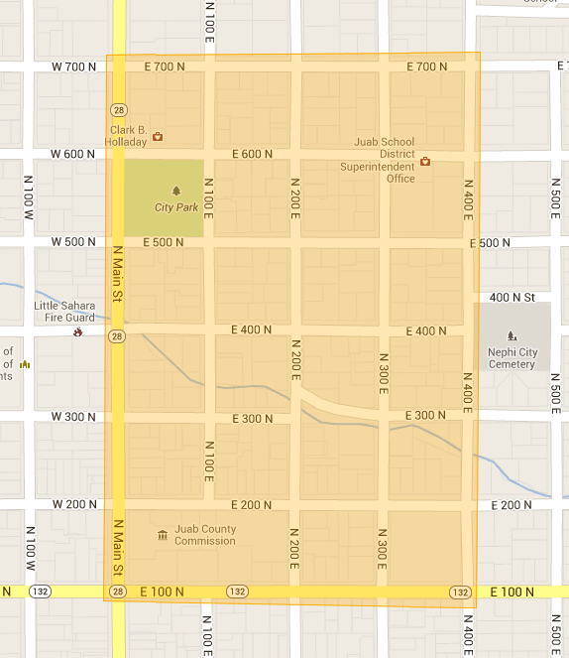
Congregation (435)864-7999

